# Abstract

This dissertation investigates the impact of alternative credit scoring systems on lending practices in the fintech loan application landscape. This study aims to replicate lender loan acceptance decisions and predict default risks by utilizing advanced machine learning techniques such as Logit and Probit Regression (LR), Support Vector Machine (SVM), and Deep Neural Networks (DNNs). The proposed two-phase model distinguishes between predicting loan rejections in the first phase and assessing default risks for approved loans in the second phase, providing insights into customer churn.

Paytm, a prominent lender, uses a credit scoring model that takes into account alternative data, such as the quality of digital transactions, to evaluate loan outcomes. However, this approach raises questions about the equitable implementation of opaque models that reshape risk assessment. The study broadens its investigation to look at fintech-bank collaborations and the capital allocation of banks participating in instant loan platforms to gain a better understanding of the situation. This analysis highlights the growing emphasis on loans facilitated by collaborations between fintech start-ups and banks, indicating a significant shift in bank balance-sheet allocation.

Alternative credit scoring systems are becoming more important in the calculative infrastructure, allowing specific institutions to overcome the challenges associated with risk-based pricing. These systems also serve as strategic collaboration points for technology start-ups and financial institutions, allowing them to capitalize on new revenue streams. The study reveals an intriguing dichotomy in model performance when loans are used for personal and business purposes. When trained on the entire dataset, the first phase outperforms the second phase, which is focused on the small business subset. This finding highlights potential differences in the screening and default prediction processes for small business loans.

This study demonstrates the power of machine learning algorithms in improving credit risk assessment, making more informed lending decisions, and accurately forecasting loan defaults. Financial institutions can improve risk management frameworks and strengthen lending practices by leveraging artificial intelligence.

Keywords: predictive model, loan defaults, customer churn, credit behaviour, technology, financial habits, instant loans, credit profile.

# Chapter 1 Introduction

Lending and borrowing money has become more complex than ever in today’s fast-changing world. In places like Bangalore, where technology is booming and people have diverse financial needs, figuring out who might not pay back their loans on time is a big challenge. Rapid advances in the fields of machine learning (ML) and artificial intelligence (AI) have resulted in the development of alternative credit scoring systems, fundamentally altering how lenders assess risk and make critical investment decisions in the realm of consumer debt. These novel models leverage unconventional data sources and sophisticated processing methods, heralding a crucial departure from the norms of risk-based pricing - a cornerstone for financial institutions. Risk-based pricing establishes interest rates based on the anticipated odds of loan defaults. In this context, the rise of alternative credit scoring, supported by algorithmic models, surpasses prevailing obstacles and ushers in a comprehensive re-evaluation of risk assessment.

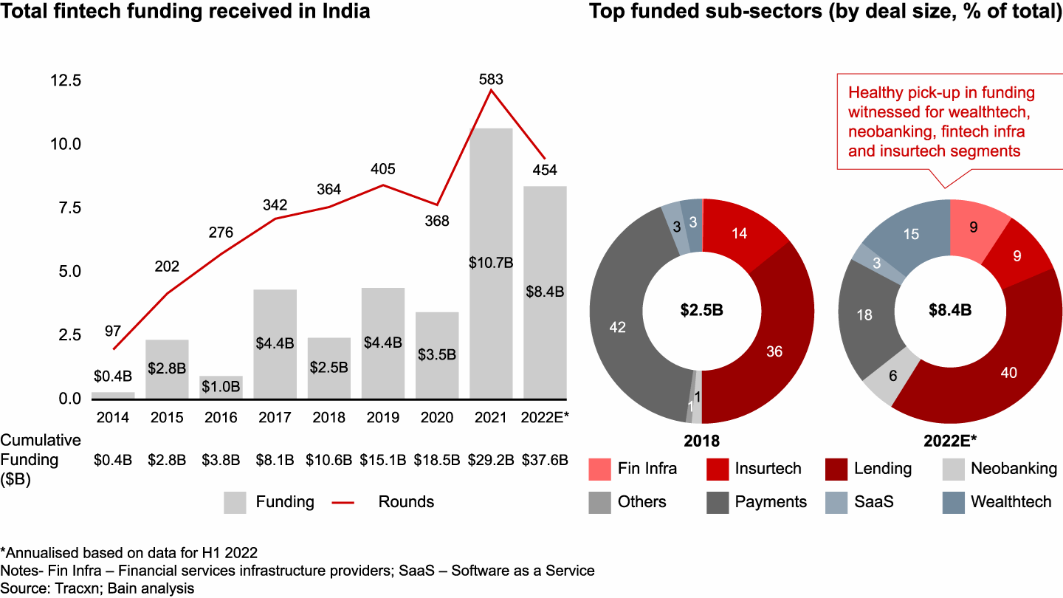

**Growth of Indian Fintech Industry**

**Source: Bain & Company** [**[1]**](https://www.bain.com/insights/india-fintech-report-2022-sailing-through-turbulent-tides/)

India is at the forefront of the FinTech revolution, with an adoption rate of 87%, which is significantly higher than the global average of 64%. The Indian FinTech market is expected to reach $1 trillion in AUM and $200 billion in revenue by 2030, according to a study conducted by EY. This rapid growth can be attributed to a number of factors, including a supportive regulatory environment, a thriving startup scene, and a young and tech-savvy population. The Indian government has played a key role in promoting FinTech adoption, through initiatives such as the Digital India program and the Unified Payments Interface (UPI). UPI has been particularly successful, enabling over 6 billion transactions per month. It has also helped to level the playing field for FinTech companies, giving them access to the same infrastructure as traditional banks.

The Indian startup scene is another major driver of FinTech growth. India is home to over 2,100 FinTech companies, which are innovating in a wide range of areas, including payments, lending, insurance, and investment. These companies are attracting billions of dollars in venture capital, which is fueling their growth. Finally, the young and tech-savvy Indian population is also playing a key role in FinTech adoption. Over 600 million Indians have internet access, and many of them are using their smartphones to access financial services. This is creating a huge opportunity for FinTech companies to reach new customers and offer them innovative products and services. The Indian FinTech industry is poised for continued growth in the years to come. The country's demographics, supportive regulatory environment, and thriving startup scene are all contributing factors. As more and more Indians adopt FinTech, the industry is expected to play an increasingly important role in the country's economy. Lending institutions rely on credit scores to evaluate borrowers' creditworthiness when applying for credit cards or auto loans. Credit scoring assesses various factors like credit history, demographics, and credit behaviour to determine approvals and interest rates. Improving credit scoring mechanisms can lead to significant financial gains and safer lending practices.

This dissertation is all about finding a smarter way to predict loan defaulters in Bangalore by analysing two key factors: customer churn and credit behaviour. By understanding these factors, lenders can better assess a borrower's ability to repay their loans and reduce the risk of default.

Banks rely heavily on lending as a source of income and financial risk. However, lending carries risks, particularly credit risk, which refers to borrowers' failure to repay the loan. To mitigate this risk, banks traditionally assess clients' creditworthiness using the 5C principle: character, capital, capacity, collateral, and conditions. Despite a rigorous verification process, there is no guarantee that the selected applicant will repay the loan on time.

In the past, banks relied on experts and statistical algorithms to evaluate creditworthiness and assign a credit score based on payment history, credit background, and other factors. This score predicted the likelihood of borrowers repaying loans, but the process required specialized expertise and was prone to errors.

India's Unified Payments Interface (UPI) has become one of the most popular payment methods in the world, enabling Peer-to-peer (P2P) and Merchant payment (P2M) transactions on smartphones, feature phones, and at merchant locations. In July 2022, P2P transactions accounted for 78% of the total transaction value, with a value of $104.595 billion, representing a 94% and 75% increase in value from the previous year. Most P2P transactions had a transaction size greater than $26 (INR 2,000).

According to the Worldpay report, India led the world in the largest daily real-time payments volume in 2021 with 70.2 million, followed by China with 42.8 million. UPI is now the leading form of retail merchant payments (Person-to-Merchant - P2M disguised as Peer-to-Peer - P2P payment) by value and volume, comparable to credit cards and debit cards. This is due to the significant increase in the number of banks going live on UPI from 2016 to 2021, reaching 297 in 2022.

The value of UPI transactions crossed $25 billion in 2019 and reached a massive $111 billion in 2022. According to the Reserve Bank of India (RBI), the overall Indian digital payment volume was 72 billion in FY21-22, with an overall transaction value of INR 1,744 trillion ($24 trillion). Driven by the growing acceptance of existing digital modes and novel payment offerings such as UPI, BBPS, and Buy-Now-Pay-Later (BNPL) schemes, the value of digital payments transactions in India is set to increase by more than 3 times by 2025. RBI's ‘Payments Vision 2025’ aims to reduce the volume of cheque-based payments.

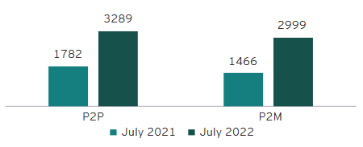

**Volume of P2P and P2M transactions**

**Source: NPCI, EY ANALYSIS [12]**

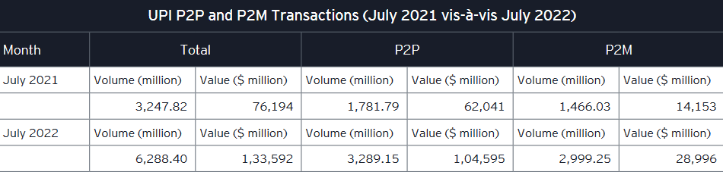

**UPI P2P And P2M Transactions**

**Source: NPCI Statistics INR to $ conversion rate considered as of 08 August 2022**

India's digital lending sector is booming, fueled by the country's rapid digitalization. By 2030, the sector is projected to account for 60% of the country's financial technology market, with the online loan market expected to hit $1.3 trillion, growing four times from $270 billion currently. At the lead of this revolution are machine learning and deep learning algorithms, which are being used by researchers and banking authorities to predict credit scores automatically. This approach streamlines the selection process for eligible loan candidates and makes it easier for people to access credit, regardless of their traditional credit history.

Digital lenders use these algorithms to assess creditworthiness and build credit history for borrowers. This is a boon for underserved segments of the population, such as small and medium-sized enterprises (SMEs), which make up 75% of MSME lending in the country.

Collaboration between banks and FinTech players can further boost credit access to these underserved segments. The Indian FinTech ecosystem is a formidable global force, generating $200 billion in revenue and $1 trillion in AUM by 2030. This partnership between banks and FinTech players can help to democratize access to credit and drive India's economic growth.

Indian banks have managed to bring down non-performing loans (NPA) in two years, but their wilful defaults rose by 38.5%, or $11.4 billion. According to a report by The Indian Express, there were 15,778 wilful default accounts worth $41.3 billion as of December 2022, compared with 14,206 accounts involving $34.1 billion a year ago. The State Bank of India (SBI) holds accounts of 1,883 wilful defaulters ($9.6 billion), followed by Punjab National Bank ($4.6 billion) and Union Bank of India ($4.27 billion), according to CIBIL data. Public sector banks account for 85% of the wilful defaults, while private banks reported 1,523 accounts for $3.3 billion as of December 2022. A wilful defaulter is a borrower who is unwilling to meet debt obligations despite having the capacity. Such an entity takes undue advantage of legal and governance loopholes, although they have been sued by their lenders. The RBI’s ‘Payments Vision 2025’ aims to curb the volume of cheque-based payments to less than 0.25% of the total retail payments and increase the number of registered users for mobile-based transactions at a CAGR of 50% by 2025. If institutional lenders face this much issues in loan defaults one can only imagine the state of things across the unregulated, digital lending space. There has been very little research among the state of things in space with special reference to Bangalore, however, this dimension will be limited to just the borrowers’ perspective, as to what factors causes the loan default and whether intentional defaults are backed by any substantial action patterns. Among financial institutions, HUDCO (Housing and Urban Development Corporation LTD) had 130 wilful default accounts for Rs 12,211 crore. Private banks reported 1,523 accounts for Rs 27,431 crore as of December 2022.

Coming from a detailed study of how Paytm, a major lending company, assesses credit using advanced computer methods, this research brings attention to the big role those different kinds of information, like having various assets as collateral, past financial behaviours and financial literacy, play in deciding if someone will be able to pay back a loan. This discovery gleams a light on the small but important details that go into deciding the risks of lending and raises important questions about fairness when using complicated credit scoring algorithms to make these decisions. This study doesn't just stick to one company; it also looks at how tech companies and banks work together. By closely looking at how banks are doing financially and how they partner with platforms like CIBIL, this research shows that there's a clear change in how money is being given out as loans.

Bangalore is a special place for this study because it's a mix of different businesses and a growing technology industry. This means lots of people have different kinds of jobs and financial situations. The research will use information from the past to make a smart system that can predict if someone might not pay back their loan in the future. Moreover, the study directs its focus onto loans sought for personal and entrepreneurial aspirations as an encapsulated domain of inquiry. Stimulatingly, the performance of computational models displays discrepancy when encompassing the entire dataset vis-à-vis concentrating on loans for small-scale business ventures. This anomaly underscores potential discrepancies in the assessment processes and mechanisms for projecting loan defaults in this specific loan category.

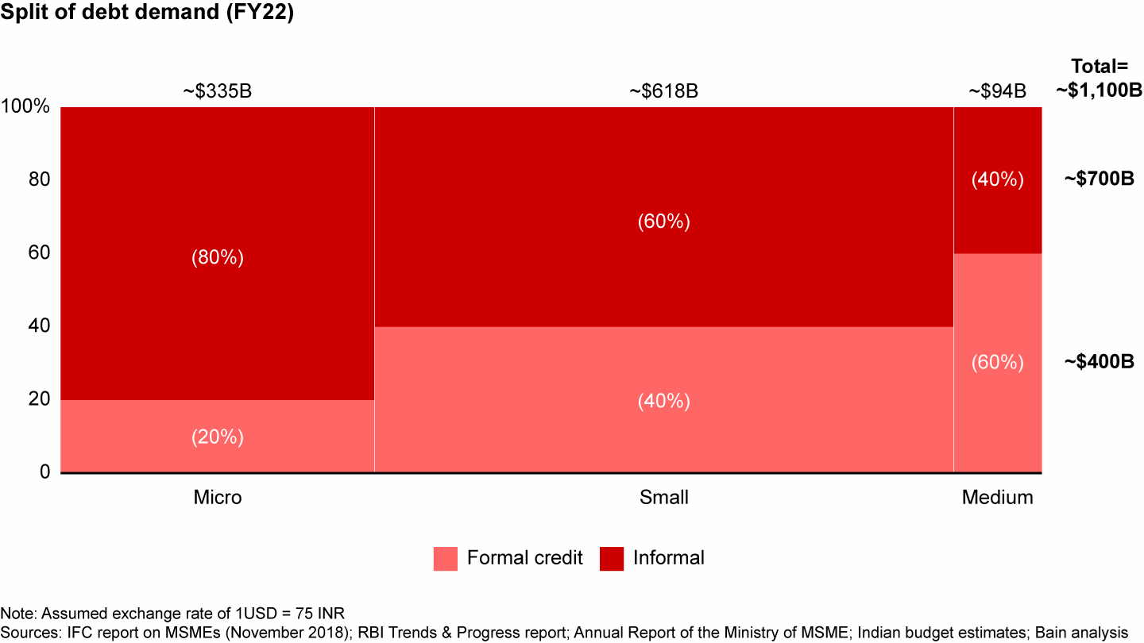

**Indian Debt Demand**

**Source: Bain & Company (Oct 2022)** [**[2]**](https://www.bain.com/insights/india-fintech-report-2022-sailing-through-turbulent-tides/)

A special attention must be brought forward in regards to the growing informal credit borrowings in India. The changing pattern in borrowing habits in Small, medium and micro businesses is yet to explored into in Bangalore. Though, it is important to note that a significant portion of the population lacks an established credit history, particularly in emerging economies where credit reporting systems may be immature. This lack of credit information hampers financial institutions' ability to establish a robust credit scoring framework that can differentiate high-risk borrowers from the larger pool of applicants, which becomes even more challenging in the context of peer-to-peer (P2P) lending platforms. Besides, the absence of credit data can lead to deserving candidates being denied access to credit. With the increasing prominence of P2P lending, payday loans, and online microlending markets in developing economies, it is crucial for financial institutions to explore more sophisticated methods of assessing borrowers' likelihood of default.

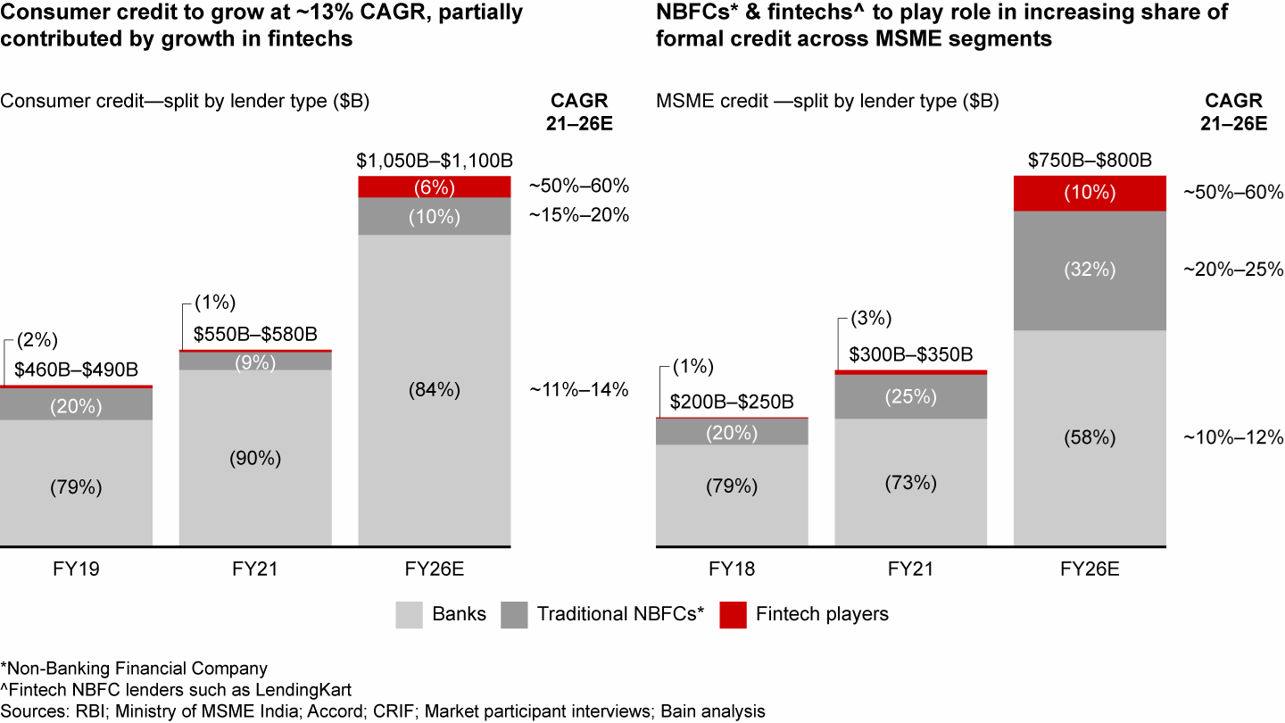

**Indian Consumer Credit Market Growth**

**Source: Bain & Company** [**[3]**](https://www.bain.com/insights/india-fintech-report-2022-sailing-through-turbulent-tides/)

Currently accounting for about 7% of India’s $1.4 trillion FS EV, the fintech sector is expected to grow to $350 billion in EV by 2026, representing nearly 15% of FS market cap. Covid-19 led to transformational shifts in consumer behaviour and accelerated digital adoption:

1. Non-cash payments soared, with more than 75% year-over-year (YoY) growth in UPI transactions between FY20–21.
2. ***Digital lending apps (DLAs) accounted for more than 60% of loans disbursed by nonbank financial companies (NBFCs) in FY21.***
3. Over 35 million demat accounts were added in FY22 (till Nov’21), thereby increasing the tally of demat accounts by 63%, from 55 million in FY21 to nearly 90 million in FY22.

While the statistics from a Bain & Company report will help us understand the growth of the Fintech sector and digital lending in India, the same cannot be said for the credit market in Bangalore, where very little research has been conducted. This is where this study comes in; the author proposes developing a system capable of identifying, categorizing, and forecasting consumers' financial behaviours.

To create this intelligent system, the author will use a type of machine learning technique known as "Deep neural network algorithms," which will be supplemented with various types of regression models. This will help us analyse all of the information we collect from people and predict whether they will have difficulty repaying the money they borrowed.

Even during the Covid-19 pandemic, loans for shopping without any security have been steadily increasing, growing by about 25% in the last three years (from FY19 to FY22):

* Credit cards have shown strength with a growth of about 19% every year.
* Personal loans have grown really well, increasing by around 29% every year.
* Loans for buying things like appliances have also bounced back to the levels before the pandemic and have grown by about 13% every year.

The growth of unsecured loans has been driven primarily by smaller towns (Tier 4), where they have grown by 32% annually over the past three years, compared to 18% annual growth in larger cities (Tier 1). North Bangalore, a mix of Tier 2 and Tier 3 geographies, is a key contributor to this growth.

The average loan size is shrinking, reflecting a shift towards smaller loans by non-banking financial companies (NBFCs) and fintech lenders. For example, the average personal loan size from NBFCs has declined by 70% over the past two years.\

For credit card loans, the smaller loans (less than $650) have been growing really well, about 12% every year for the last three years. This is happening mostly in the smaller towns. Personal loans for smaller amounts (less than $650) have been growing really fast too, about 120% every year, and most of these loans (85%) are given to people younger than 35. Just like credit card loans, this growth is also happening more in the smaller towns. Loan prediction is a hot topic in the banking and finance sectors. Credit scoring plays a vital role in this highly competitive financial landscape. With the recent advancements in data science and artificial intelligence, there's been a surge in interest and research in this field. Loan prediction and credit risk assessment have become the centre of attention in recent years due to the increasing demand for loans.

The FinTech sector in India has experienced a significant surge in funding over the past few years, attracting massive investment from large venture capital and private equity firms. FinTech companies capitalized on the rising demand for digitization of financial services during the COVID-19 pandemic. In 2021, the Indian FinTech market witnessed an investment of $8 billion, producing over 15 FinTech unicorns during the year. The Indian FinTech ecosystem is one of the fastest-growing in the world, with a FinTech adoption rate of 87% against the global average of 64%. The Indian FinTech industry is projected to reach $190 billion in revenue by 2030, with a transaction value of $138 billion in 2023. The growth of the Indian FinTech industry can be attributed to various factors, such as government initiatives, a thriving funding environment, a thriving VC ecosystem, high FinTech adoption, and access to talent and technology. The collaboration between banks and FinTech players can boost credit access to the underserved segment and SMEs, which will continue to be a massive opportunity for FinTech.

The demand for improved credit scoring and loan prediction models has skyrocketed. Over the years, various techniques have been employed to assign credit scores to individuals, and extensive research has been conducted on this subject. Unlike the past, where experts made credit assessments based on professional judgments, the focus has shifted towards automated methods.

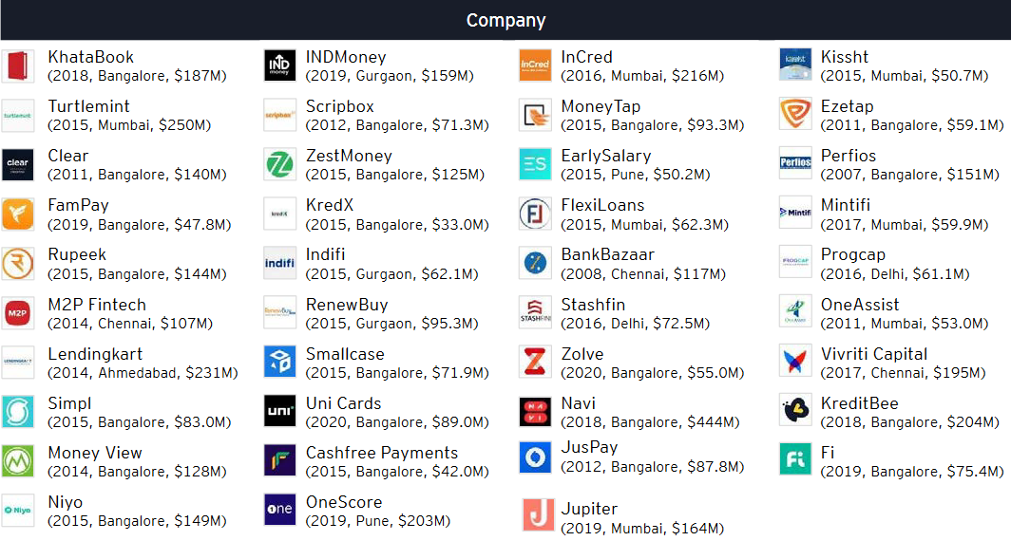

**Digital Lending Soonicorns in India   
Source: EY** [**[11]]**](https://www.google.com/url?sa=t&rct=j&q=&esrc=s&source=web&cd=&ved=2ahUKEwjQgImRqJiBAxWG2TgGHTV2BmEQFnoECC0QAQ&url=https%3A%2F%2Fassets.ey.com%2Fcontent%2Fdam%2Fey-sites%2Fey-com%2Fen_in%2Ftopics%2Fconsulting%2F2022%2Fey-winds-of-change-india-fintech-report-2022.pdf%3Fdownload&usg=AOvVaw3xRJh_4QXIF1yNDD2CX7jP&opi=89978449)

A Soonicorn is a company that is likely to achieve a US $1 billion valuation in the short to medium term

A very important trend in India, according to EY, is that Paytech is consolidating, Payment players are among the leading acquirers of digital lending start-ups in India. Between 2015 to 2021, seven digital lending payers got acquired by payment companies. It was followed by five deals where another lender acquired the digital lending start up

Loans for buying appliances in smaller amounts have also bounced back, growing by about 11% every year in the last three years. More than 70% of these loans have been given to people under 40, with about 36% going to people aged 30 to 40, and 37% to people under 30. This shows that many younger people, like millennials and Gen Z, want loans for buying things. Further secondary research indicates a trend of, people who are getting a loan for the first time are really good at repaying their credit card loans, but they are having some trouble repaying personal loans and loans for appliances.

All of this shows that there is a clear trend towards smaller loans for shopping, especially among younger people. The growth in the smaller towns and among new customers also tells us that companies are using the internet more to give out loans and using different kinds of information to decide who should get a loan.

A big part of this research is understanding how people who might not have a good credit history – like those who borrow money instantly without much checking – can still be understood and predicted. These risky loans are a big challenge, and we want to figure out how to make lending money to these people safer for everyone.

At a high level, this dissertation explores how new technology can be used to better understand people's financial habits and predict their likelihood of defaulting on loans. This research could help to make lending and borrowing more secure and reliable, and to shed light on the evolving process of credit scoring. The dissertation examines a variety of successful machine learning techniques for developing credit scoring models for imbalanced populations and sample sizes, taking into account both quantitative and qualitative factors that may or may not directly influence borrowers' ability to repay their loans. It also explores the potential for collaboration between technology companies and banks to improve credit scoring and lending practices in Bangalore.